What kinds of non-citizens can apply for FEMA Benefits?
* To apply for FEMA benefits, at least one member of your household must be a U.S. citizen or an eligible non-citizen. Eligible non-citizens are legal permanent residents (green card holders), asylum seekers, refugees, and some victims of severe abuse or trafficking. Essentially, these requirements are the same as the citizenship requirements for federally funded cash assistance programs like TANF.
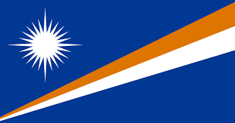
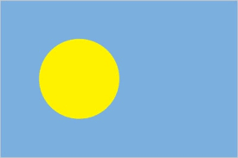
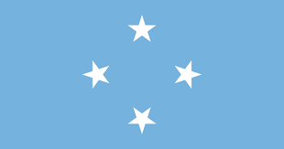
* People who came to Guam from the Federated States of Micronesia, Palau or the Republic of the Marshall Islands under the Compacts of Free Association (COFA Migrants) are not eligible non-citizens unless they have a green card or another eligible immigration status.

How can COFA Migrants get help?
* COFA migrants can still apply for FEMA benefits if at least one person in their household has an eligible citizenship status. Because everyone born on Guam is a U.S. citizen, this means that if you have any children in your household who were born on Guam, your household is eligible for benefits.
* To access these benefits, you need to apply as a co-registrant with the eligible member of your household. You will need to have a copy of the eligible household member’s Social Security card.

If I have a U.S. citizen child, what benefits can I get?
*If a child is the only person in your household with an eligible immigration status, you are still eligible for most of FEMA’s standard cash benefits. These include cash assistance of up to $41,000 to repair or replace the home you own and live in, if it was damaged by the disaster; if you have to stay in a hotel or other temporary housing while the home you own or rent is replaced or repaired, some of your temporary housing costs; and if your essential personal property (car, clothing, critical appliances, items you need to clean up after or prepare for the next typhoon) was damaged or destroyed, up to $41,000 to repair or replace essential personal property.
* COFA Migrants may still be required to be rejected by the SBA for a loan before they can complete an application for grant assistance for essential personal property.

Can COFA Migrants get SBA Loans?
* SBA loans are only available to qualifying U.S. citizens and eligible non-citizens. Qualifications are based on your income and credit score. If the only eligible non-citizen in your household is a child younger than 18, then your household will likely also be ineligible for SBA loans, as children under 18 are generally ineligible for loans. This means that COFA households usually cannot get SBA loans unless there are adults in the household who are U.S. citizens or eligible non-citizens.
* Because FEMA has to determine that a household is ineligible for an SBA loan before the household can be considered for FEMA cash assistance for essential personal property, this means that your household will likely be eligible for cash assistance of up to $41,000 to repair or replace essential personal property that was damaged or destroyed by the disaster.

What help can I get if I am not Eligible for FEMA Benefits?
* Mass Assistance: Under this program, the federal government provides supplies directly to disaster survivors. There are no citizenship requirements for this assistance. On Guam, items being distributed through Mass Assistance are usually available at Mayors’ offices – these items are usually provided at all Mayors’ offices, so you can pick up supplies from any Mayor’s Office.
* Counseling: Living through a disaster is difficult. There are a number of free counseling hotlines available to all disaster survivors, including 1-800-985-5990.
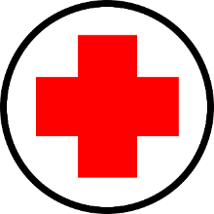
* American Red Cross: The Red Cross provides a number of different types of assistance – they provide temporary shelters, and in some cases cash assistance for temporary roof repairs, propane for cooking, and other essential items that will allow you to return to your damaged home in the short term. They also provide case management services, so you have access to a case manager who will help you connect with other resources. To apply for Red Cross cash and case management assistance, you can call 1-800-733-2767.
* The Salvation Army: Similar to the Red Cross, the Salvation Army can provide temporary shelters, food, clothing, and other assistance in the immediate aftermath of a disaster. There is no citizenship requirement for their services. They may also be able to provide longer term assistance to help you rebuild – however, this type of assistance is not available for every disaster.
* Free Legal Services: After a disaster, free legal services are provided to disaster survivors. While there are immigration restrictions on disaster legal assistance, citizens of the Federated States of Micronesia, Palau and the Republic of the Marshall Islands are eligible for free legal services – as long as they meet the other income based eligibility criteria. On Guam, for typhoon Mawar, Micronesian Legal Services Corporation is the provider of free legal assistance for disaster survivors.
* Shelters: In addition to the temporary shelters set up before the typhoon by the Government of Guam, new shelters will continue to open with the support of entities like Catholic Social Services, the Red Cross and the Salvation Army.
* Local Assistance: After disasters, local governments may also set up free programs for disaster survivors. Free water refill stations, waste disposal sites, trash pick-up, and other services may be available. On Guam, Mayors’ offices, and local news organizations can help you identify the other assistance that is available.

Non-Traditional Sources of Help
If you need help, ask! Your neighbors and other members of your community may be able to personally help you. If you are not eligible for other types of assistance, crowd-funding platforms like Go Fund Me may enable you to raise the money you need for repairs.

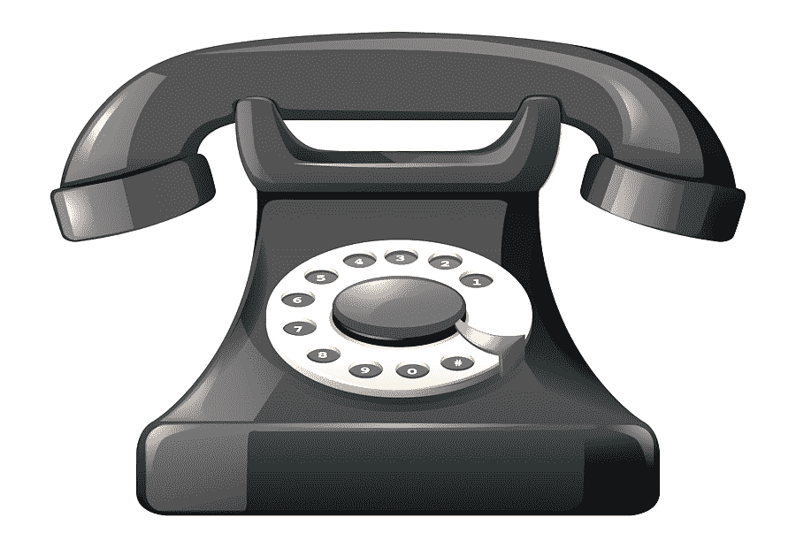

Important Contacts:
FEMA: 1-800-621-3362
FEMA application for speech or hearing disabled—1-800-462-7585 (TTY)
FEMA online application: www.DisasterAssistance.gov
American Red Cross Application: 1-800-733-2767
The Salvation Army: 1-671-472-7671

Micronesian Legal Services Corporation - Guam
928 Archbishop Flores Street
DNA Building Suite 902
Hagåtña, GU 96910
(671) 969 -5504/5604/5704
guam@mlscnet.org
www.micronesianlegal.org

This brochure was prepared by the Guam Office of MLSC and is provided as a public service.
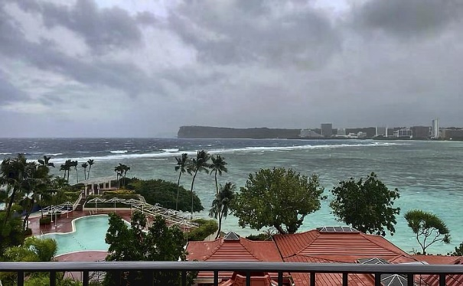

Disaster Recovery Benefits for non-U.S. Citizens

MLSC’s mission is to promote equal access to justice and to provide free civil legal assistance to low income people. MLSC improves the lives of Guam’s residents by helping them solve their important legal problems and strengthening communities through advocacy.

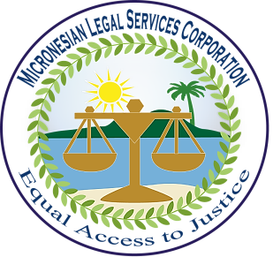

June 2023

